**SIMULATION OF VCO OF PLL**

**Circuit Diagram:**

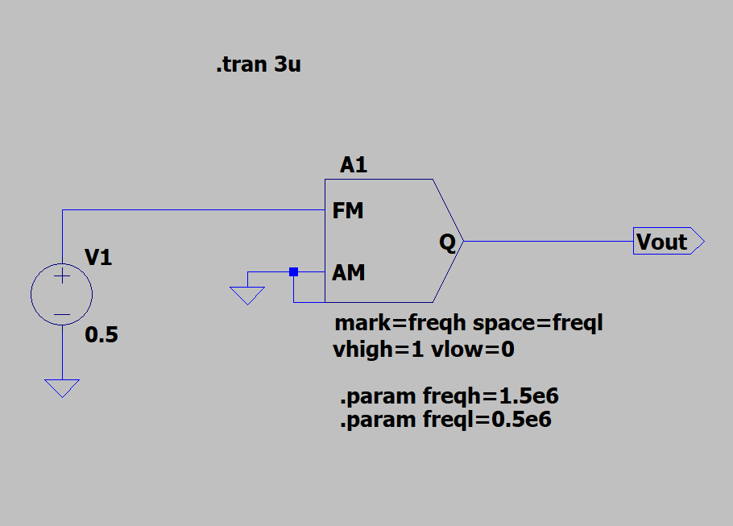

**Output:**

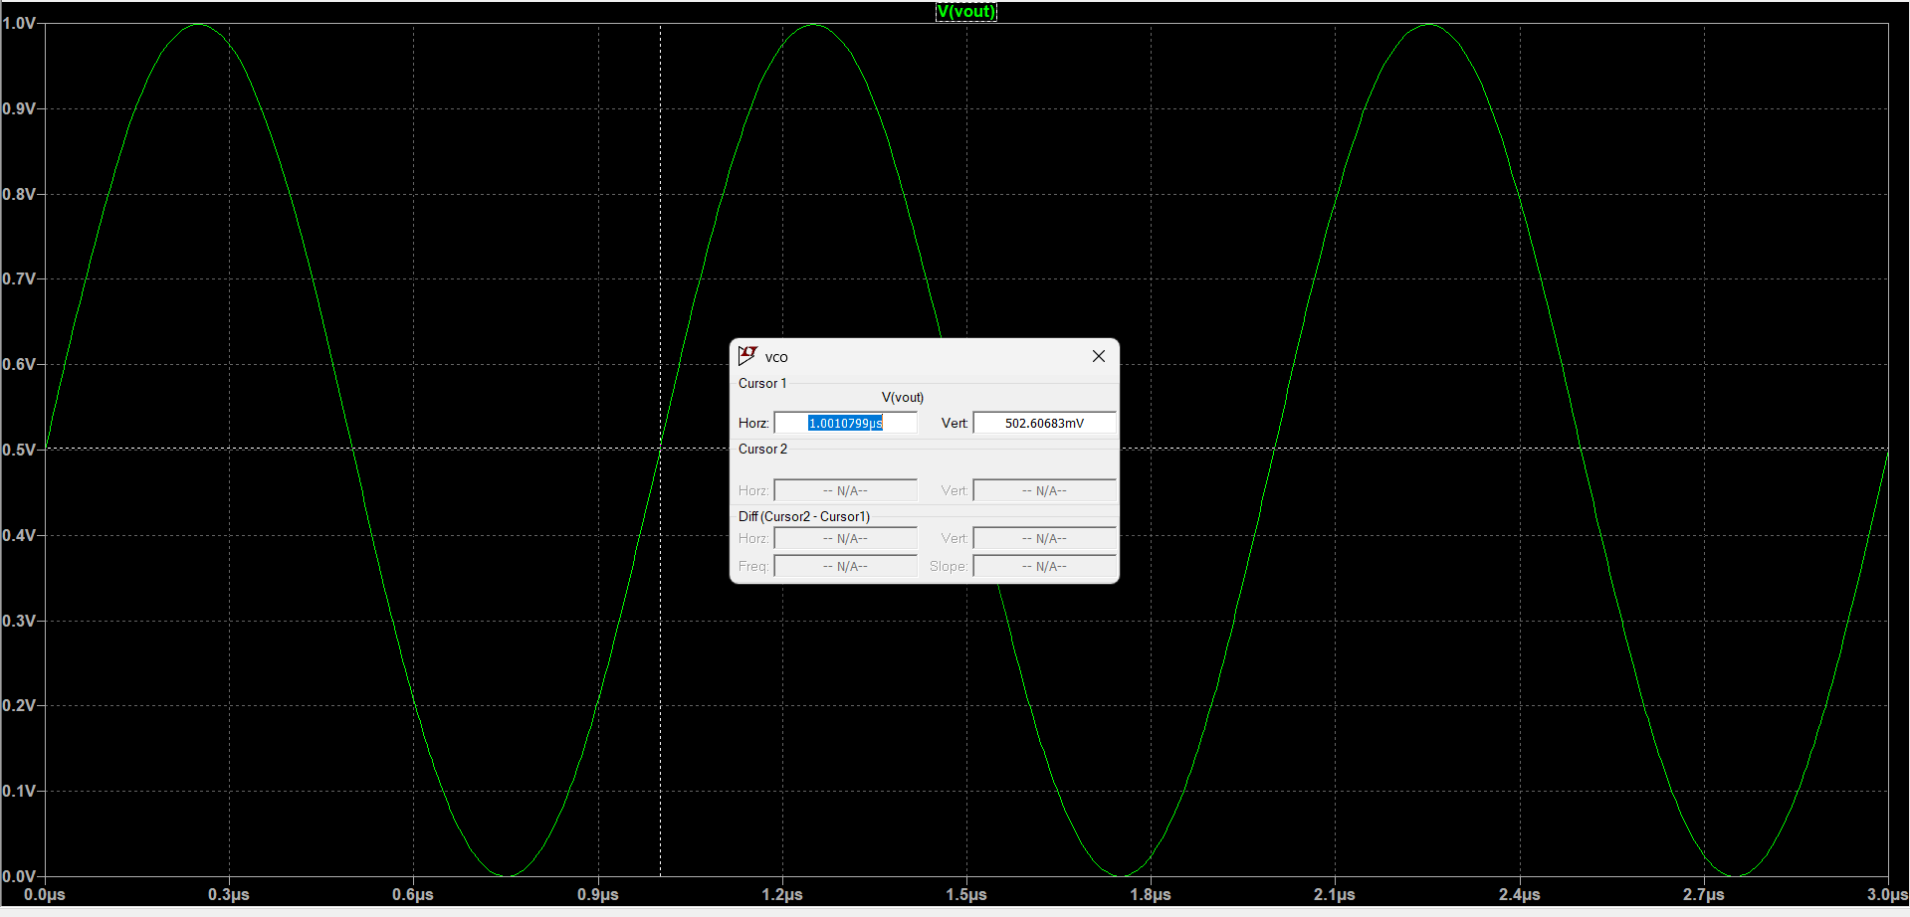

**Calculation:**

